1. want to know the number of rows in our data set

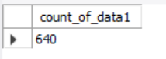 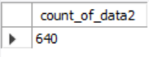

1. want to find data for Uttar Pradesh and Bihar only

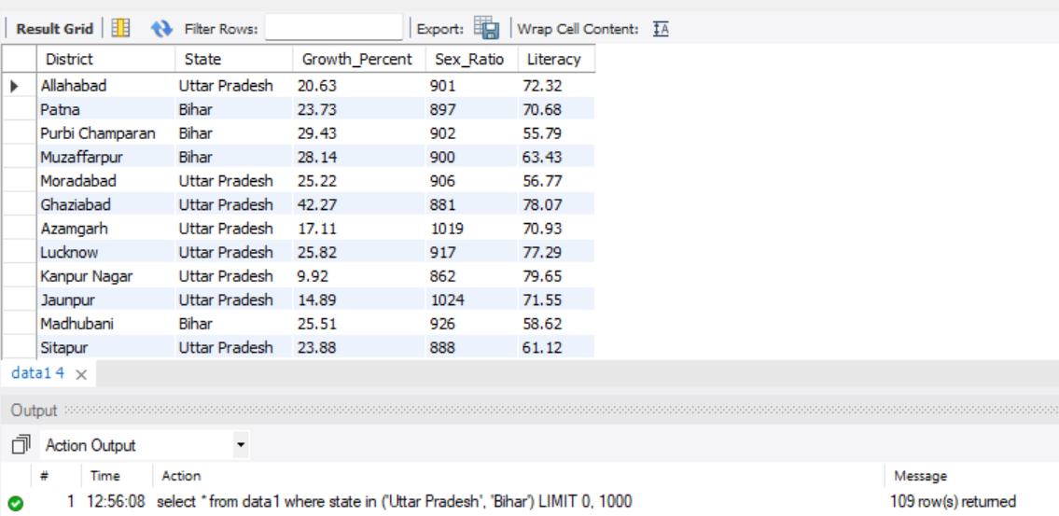

1. want to know total population

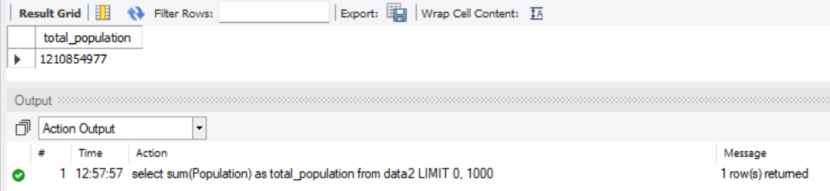

1. Average Growth by state

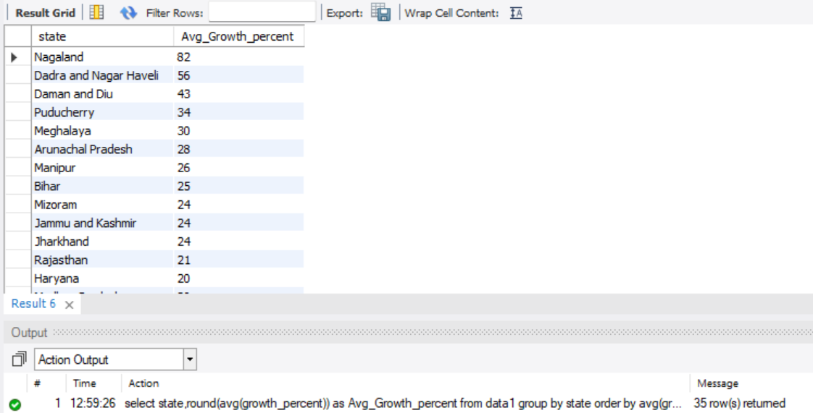

1. Average Sex Ratio by state

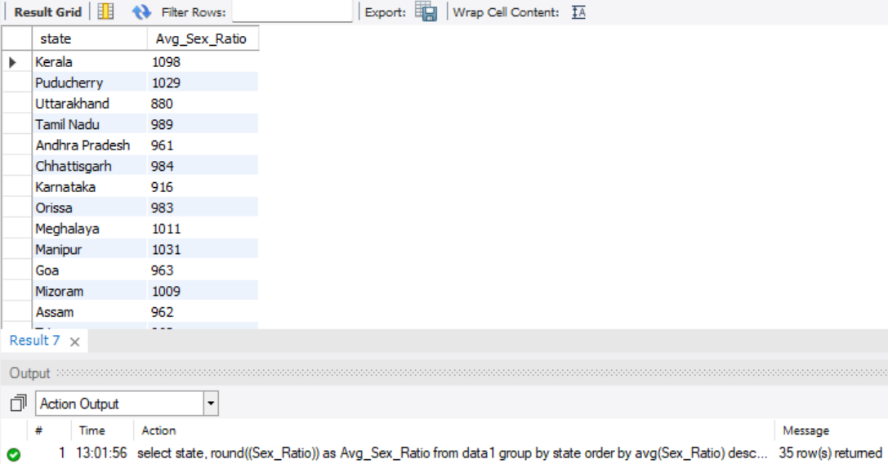

1. Average Literacy Rate by state

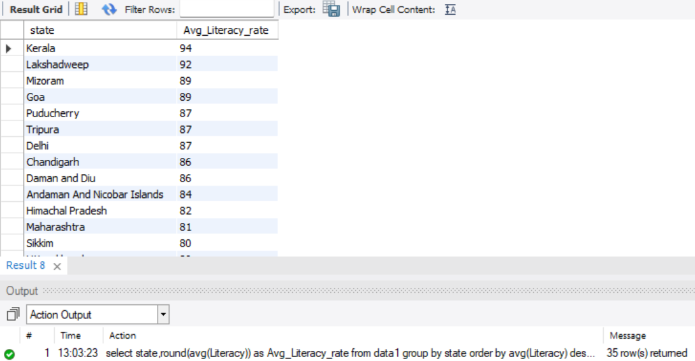

1. How many states having Literacy rate greater than 90%

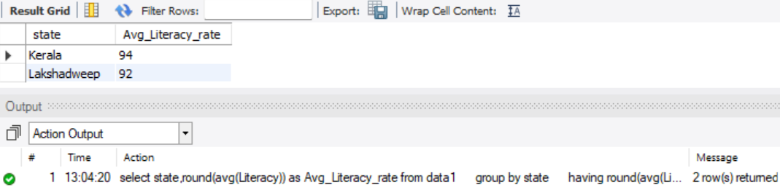

1. Top 3 states showing highest growth ratio

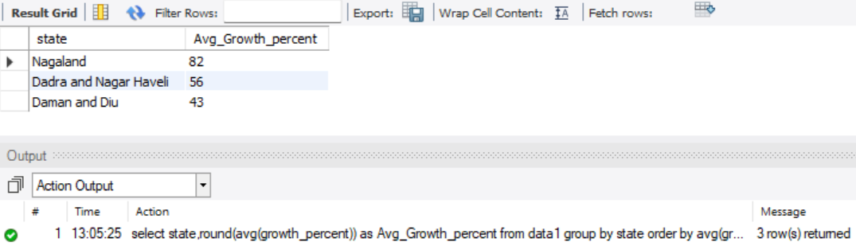

1. list of 5 states having lowest sex ratio

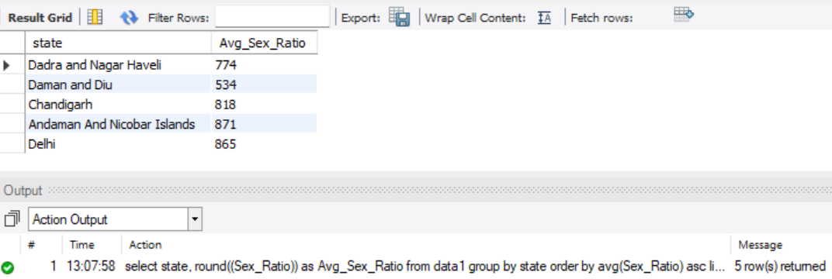

1. top and Bottom 3 states in literacy ratio

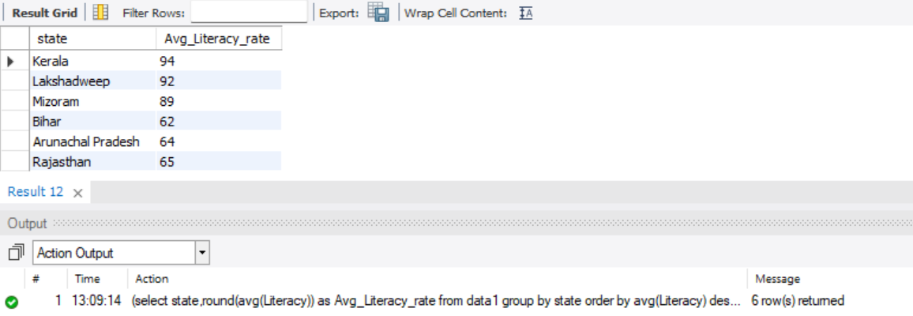

1. Filter out the states starting with letter 'a'

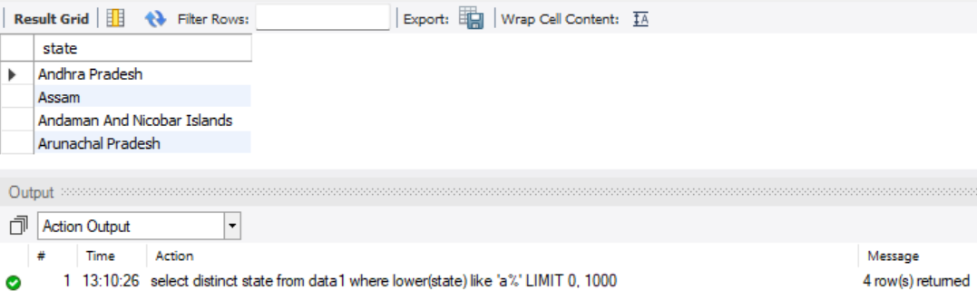

1. Find count of males and females statewise

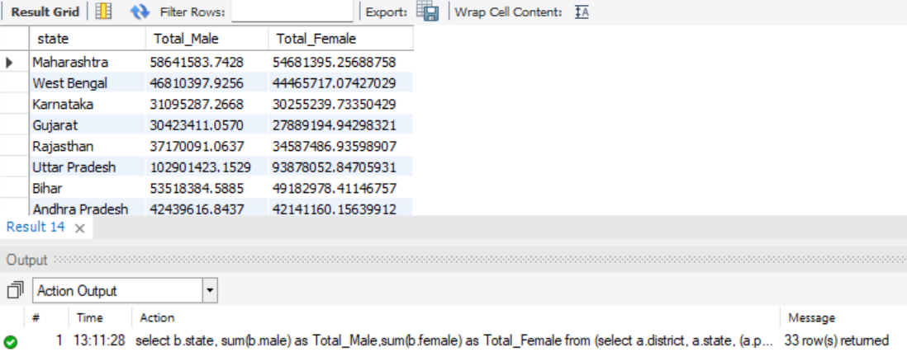

1. Find count of total Literate and Illiterate Peoples Statewise

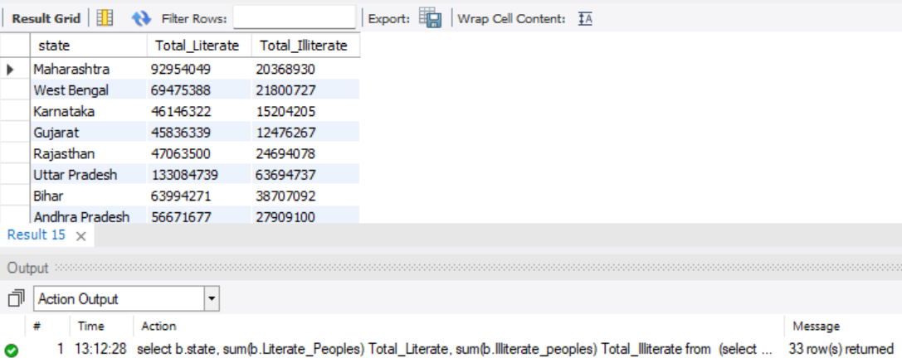

1. Population in Previous Census

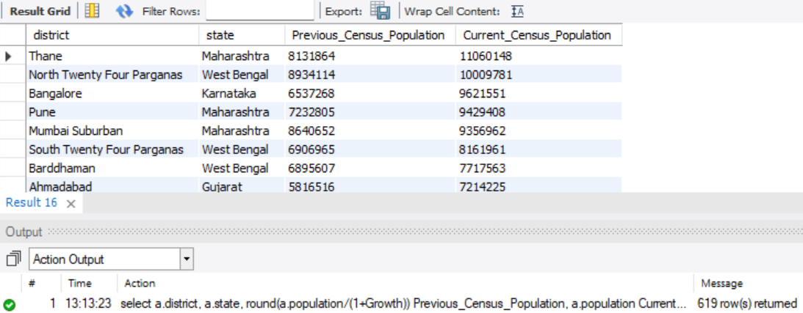

1. Want to Know what is the total Population In Prev. Census and the current Census

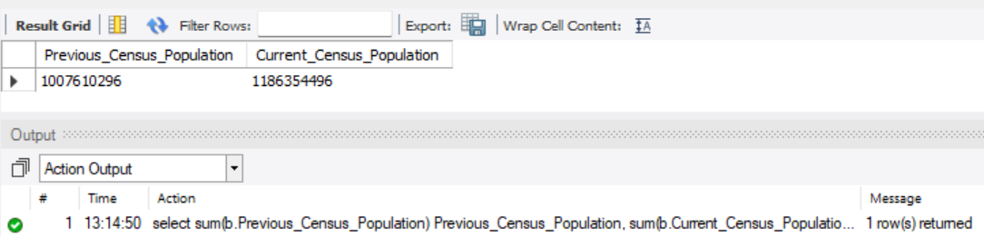

1. Population by Area

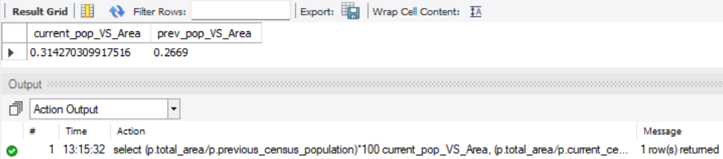

1. Using Window Functions find top 3 district from each state with highest literacy rate

